EXPERIMENT 4

1.Aim : To perform Online Analytical Processing (OLAP) operations using Microsoft Power BI by creating multidimensional reports and applying Slice, Dice, Drill-down, and Drill-up operations on the Global Superstore dataset for analytical decision-making.

2. Tools / Software Required
- Microsoft Power BI Desktop
- Global Superstore Dataset.xlsx
- Power Query Editor
- DAX (Data Analysis Expressions)

3. Theory
Dimensional Modeling is a data warehouse design technique used in Business Intelligence systems to support analytical processing. It organizes data into Fact Tables and Dimension Tables. Fact Tables contain measurable business events and numerical values such as Sales, Profit, Quantity, and Discount. Dimension Tables contain descriptive attributes such as Customer, Product, Region, and Date. A Star Schema consists of a central Fact Table connected to multiple Dimension Tables. The Fact Table stores transactions and measures, while Dimension Tables provide the context for analysis. Star Schemas simplify reporting, make filtering easier, and support efficient analytical processing.

Fact Table and Dimension Tables
Table Type | Table | Main Columns
Fact | Fact_Sales | Order ID, Customer ID, Product ID, Region, Order Date, Sales, Quantity, Profit, Discount
Dimension | Dim_Customer | Customer ID, Customer Name, Segment
Dimension | Dim_Product | Product ID, Product Name, Category, Sub-Category
Dimension | Dim_Region | Region
Dimension | Dim_Date | Date, Year, Quarter, Month, Month_Number

4. Procedure / Implementation Steps

Part A – Load Dataset
- Open Microsoft Power BI Desktop.
- Select Home → Get Data → Excel Workbook.
- Select Global Superstore Dataset.xlsx.
- In the Navigator window, select the Orders, Returns, and People worksheets.
- Click Load and verify that the imported tables appear in Power BI.

Part B – Open Power Query
- Select Home → Transform data → Transform data to open Power Query Editor.
- The Queries pane should contain Orders, Returns, and People.
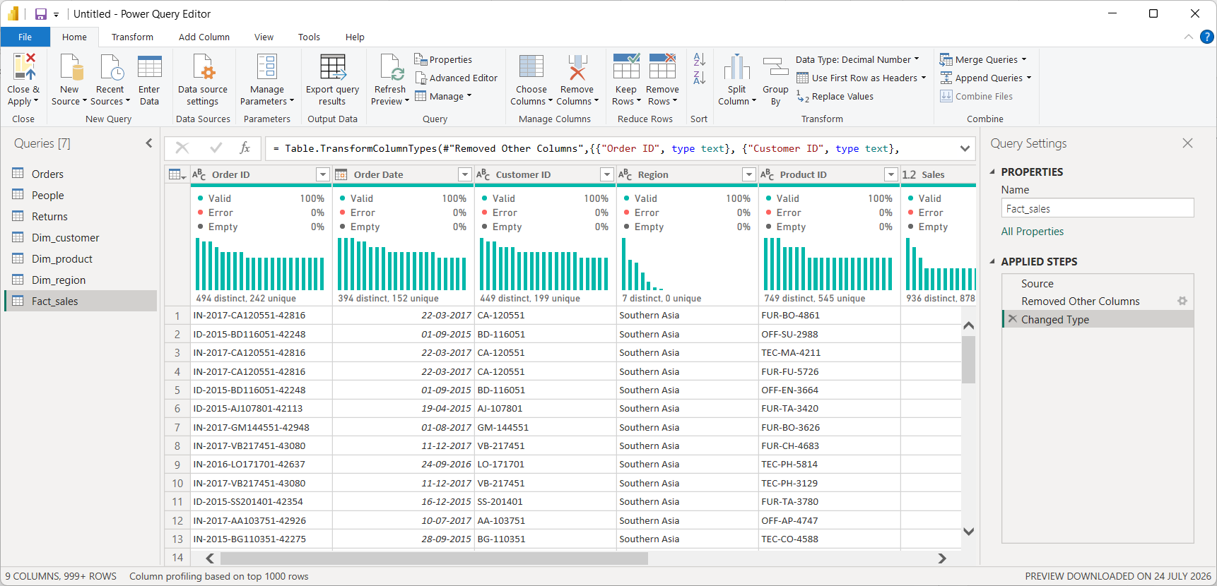

Part C – Create Dim_Customer
- Right-click the Orders query and select Reference.
- Rename the new query to Dim_Customer.
- Keep only Customer ID, Customer Name, and Segment.
- Select Customer ID → Home → Remove Rows → Remove Duplicates.
- Verify that each Customer ID occurs only once in Dim_Customer.

Part D – Create Dim_Product
- Right-click Orders → Reference.
- Rename the new query to Dim_Product.
- Keep Product ID, Product Name, Category, and Sub-Category.
- Select Product ID → Remove Rows → Remove Duplicates.
- Verify that Product ID is unique in Dim_Product.

Part E – Create Dim_Region
- Right-click Orders → Reference.
- Rename the query to Dim_Region.
- Keep the Region column for the simple Region-based star-schema relationship used in this experiment.
- Select Region → Remove Rows → Remove Duplicates.
- Verify that each Region occurs only once.

Part F – Create Fact_Sales
- Right-click Orders → Reference.
- Rename the new query to Fact_Sales.
- Keep Order ID, Customer ID, Product ID, Region, Order Date, Sales, Quantity, Profit, and Discount.
- Remove all other unnecessary columns.
- Check the data types: IDs and Region as Text, Order Date as Date, Sales/Profit/Discount as Decimal Number, and Quantity as Whole Number.
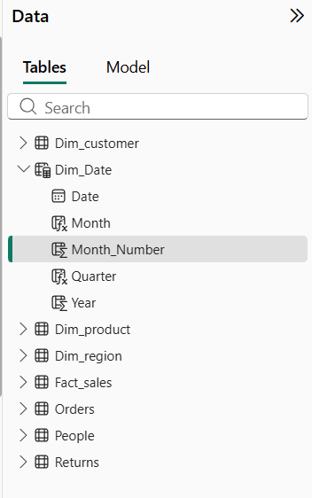

Part G – Apply Power Query Changes
- Select Home → Close & Apply.
- Wait for Power BI to load the transformed tables.
- Verify that Dim_Customer, Dim_Product, Dim_Region, and Fact_Sales are available in the model.

Part H – Create Dim_Date using DAX
Go to Modeling → New Table and enter:
Dim_Date =
CALENDAR(
MIN(Fact_Sales[Order Date]),
MAX(Fact_Sales[Order Date])
)
Create the following calculated columns using Modeling → New Column:
Year: Year = YEAR(Dim_Date[Date])
Quarter: Quarter = "Q" & FORMAT(Dim_Date[Date], "Q")
Month: Month = FORMAT(Dim_Date[Date], "MMMM")
Month Number: Month_Number = MONTH(Dim_Date[Date])
To display months chronologically, select Dim_Date[Month] → Column tools → Sort by column → Month_Number.

Part I – Build the Star Schema
Open Model View. Arrange Fact_Sales in the center and place the dimension tables around it.
Expected layout:
Dim_Customer
|
Dim_Product ---- Fact_Sales ---- Dim_Date
|
Dim_Region

Part J – Create Relationships
Dimension | Dimension Column | Fact Table | Fact Column | Relationship
Dim_Customer | Customer ID | Fact_Sales | Customer ID | 1 : *
Dim_Product | Product ID | Fact_Sales | Product ID | 1 : *
Dim_Date | Date | Fact_Sales | Order Date | 1 : *
Dim_Region | Region | Fact_Sales | Region | 1 : *

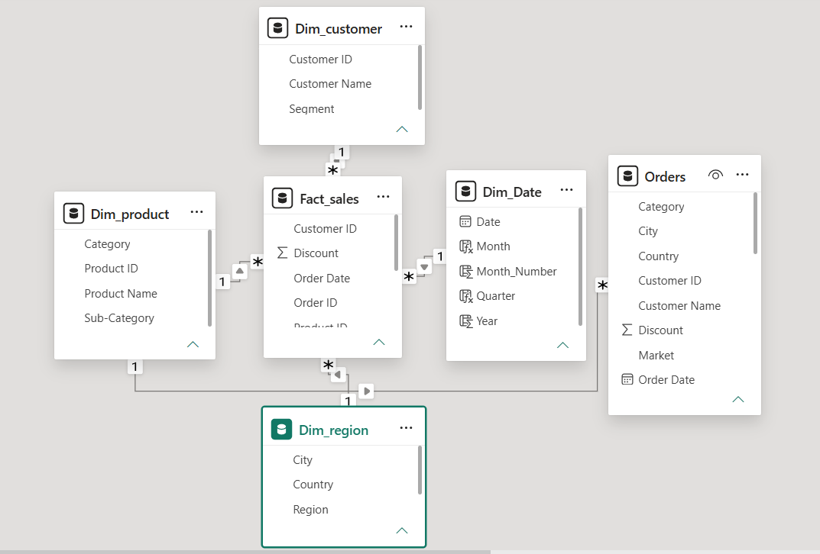

Part K – Create DAX Measures
Total Sales
Total Sales =
SUM(Fact_Sales[Sales])
Total Profit
Total Profit =
SUM(Fact_Sales[Profit])
Profit Margin
Profit Margin =
DIVIDE(
[Total Profit],
[Total Sales],
0
)
Average Order Value
Average Order Value =
DIVIDE(
[Total Sales],
DISTINCTCOUNT(Fact_Sales[Order ID]),
0
)
Create Total Sales and Total Profit before creating Profit Margin because Profit Margin uses those measures. Format Profit Margin as Percentage using Measure tools → Format → Percentage.
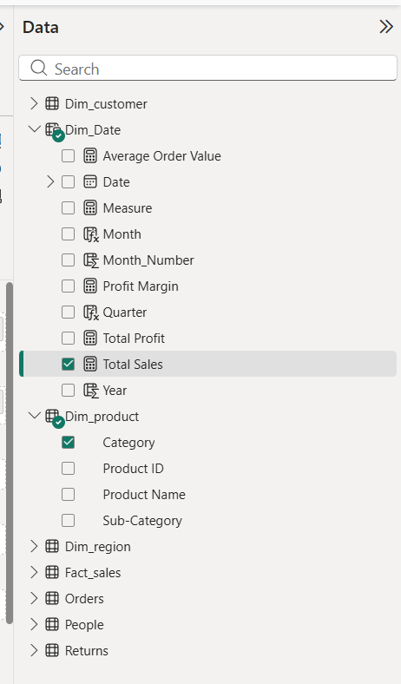

Part L – Create Visualizations
- Sales by Category: Insert a Clustered Column Chart. Use Dim_Product[Category] on the X-axis and [Total Sales] as Values.
- Profit by Region: Insert a Bar Chart. Use Dim_Region[Region] as the category and [Total Profit] as Values.
- Sales Trend by Year: Insert a Line Chart. Use Dim_Date[Year] on the X-axis and [Total Sales] as Values.
- Create Card visuals for Total Sales, Total Profit, Profit Margin, and Average Order Value.
- Add slicers such as Dim_Date[Year], Dim_Region[Region], and Dim_Product[Category] for interactive filtering.

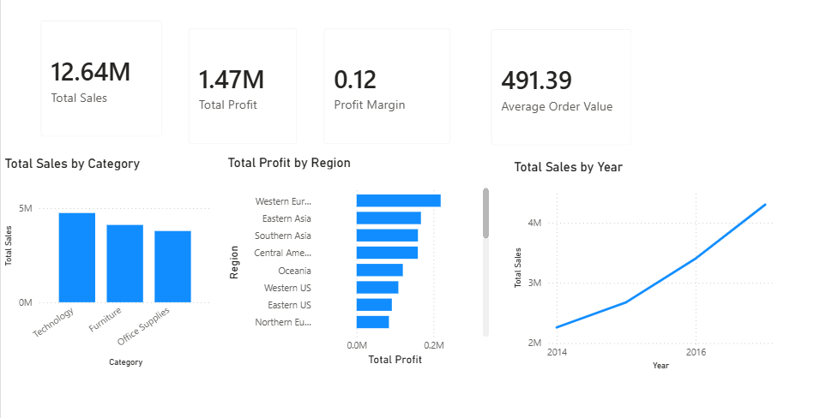

Part M Slice Operation
Slice means selecting a single value from one dimension. In this experiment, Region = Central Africa is used as the slice.
Step 1: Click an empty area of the report page and select the Slicer visual.
Step 2: Drag the Region field into the slicer's field area.
Step 3: Select Central Africa from the Region slicer.
Step 4: Observe how Sales, Profit, Segment, Category, and other visuals change.
Step 5: Capture a screenshot showing Region = Central Africa and the changed visuals.
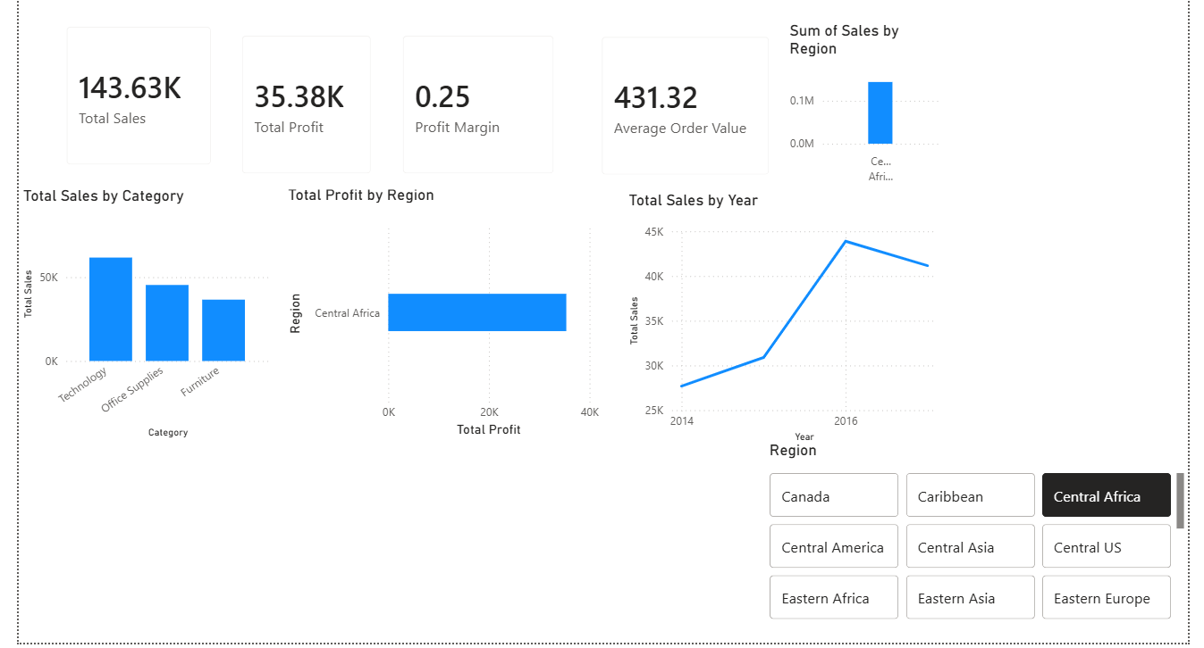
Part N Dice Operation
Dice means applying multiple filters from multiple dimensions at the same time.
The example combination is:
- Region = Central Africa
- Category = Technology
- Year = 2015
Step 1: Create a second Slicer visual and add Category.
Step 2: Select Technology.
Step 3: Create a third Slicer visual and add Year.
Step 4: Select 2015.
Step 5: Keep Region = Central Africa selected in the first slicer.
Step 6: Observe the business metrics for Technology products in West during the selected year.
Step 7: Capture a screenshot showing all three filters.
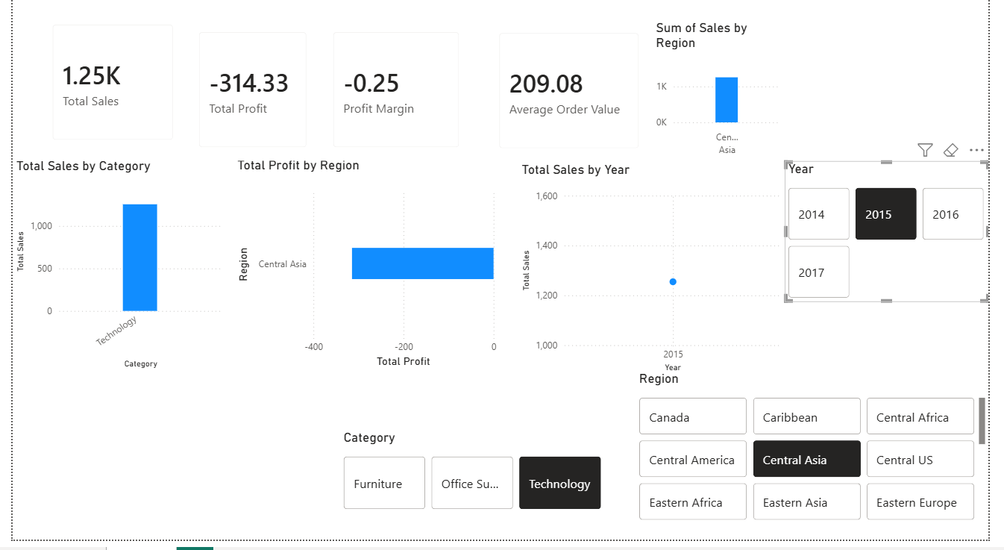
Part O Drill-up Operation
Drill-up is the reverse of drill-down. It moves from detailed data back toward summarized data.
Step 1: From City level, use the Drill-up control on the visual.
Step 2: The chart moves from City level to State level.
Step 3: Use Drill-up again to move from State level to Region level.
Step 4: Compare the aggregated values at City, State, and Region levels.
Step 5: Capture screenshots showing the drill-up process.

5. Result
OLAP operations Slice, Dice, Drill-down, and Drill-up were successfully implemented in Microsoft Power BI using the Global Superstore dataset. The report enabled multidimensional analysis of sales and profit by applying filters, slicers, and the Region → State → City hierarchy, providing both detailed and summarized views for effective business decision-making.

6. Learning Outcomes
- Explain dimensional modeling concepts and Star Schema architecture.
- Differentiate between Fact and Dimension tables.
- Design dimensional models using real-world business datasets.
- Create and validate Star Schemas in Power BI.
- Develop DAX measures for analytical reporting.

